# Market Research

## Age Demographic

* Gen Z (18-24) - Commonly just started to enter the pet ownership market, often favoring cats or smaller, easier-to-manage animals. Prefer adopting as it’s also more cost efficient
* Millennials (25-40) - Represents the largest segment of pet owners. They are known to delay traditional milestones such as home ownership or starting a family, often substituting with pet ownership.
* Baby Boomers (57-75) - They adopt pets to combat loneliness and maintain an active lifestyle, particularly dogs for companionship and walking.

## Income

* Middle to Upper level – Owning a pet is pretty costly
* Young professionals

## Location + Lifestyle

* Urban Vs Rural – Urban residents prefer smaller companions as that’ll fit more into their lifestyle whereas Rural residents tend to get bigger digs as they’ll have more space to roam
* Couples/Singles - Without children

## Pet Types

* Cats - More common among younger adults, singles, and apartment dwellers
* Dogs - More popular among homeowners, families, and those living in suburban or rural areas

## Gender Differences

* Women - More likely to adopt pets, particularly cats, than men. Women are also more likely to advocate for and participate in rescue and adoption efforts

## Family Dynamics

* Empty Nesters – Older adults that adopt pets to fill loneliness
* Families with children - Families with children often adopt pets to teach responsibility and provide companionship for their kids

# GROUP PROJECT REQUIREMENTS

* A listing of available cats/dogs with basic information.
* Have a button for an online questionnaire for potential adopters with 5-10 questions to determine if they are a good option to adopt a pet.
* A button to direct employees to a page that shows all of the submitted potential adopter forms, ones that have been approved/denied/awaiting approval.
* A login page for both users and employees.
* A selection ability for the users to select a desired pet.
* An ability for employees to add/delete/update pets.
* An option/tab for PAO management to see what users are currently watching/interested in each pet.
* NON FUNCTIONAL
  + The response time between screens must be less than 5 seconds with a 99% confidence level.
  + The system should require strong passwords.
  + The system should be available during business hours.
  + A system that validates user input to protect it from outside hacking trying to get their data.
  + The system will shut down automatically when detecting a potential threat.
  + The app should be operable and maintain a consistent user experience across mobile devices and browsers.

# Personas

## Jacky Li – User Persona

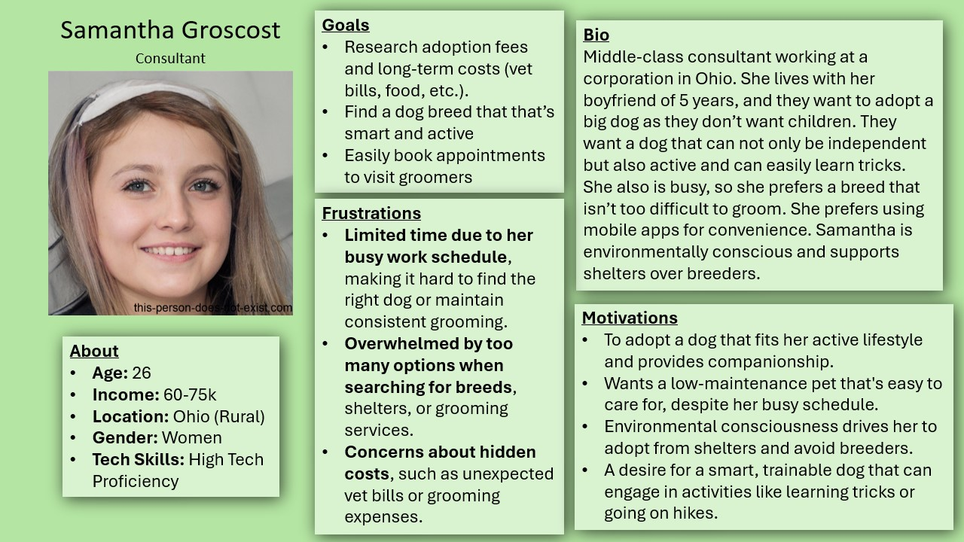

### Scenario:

Samantha, a busy consultant, logs into the Pet Adoption website to find a large, active, low-maintenance dog. She uses filters to search for dogs that match her needs, quickly discovering a Border Collie named Max, known for his intelligence and trainability. After reviewing Max’s grooming requirements and a transparent breakdown of adoption costs, Samantha uses the site’s booking feature to schedule a visit to the shelter. The process is seamless, efficient, and aligns perfectly with her busy lifestyle, leaving her excited to meet Max and potentially adopt him.

### User Story:

1. As a busy professional, I want to quickly filter pets by size, activity level, and grooming needs so that I can find a dog that fits my lifestyle.
2. As a potential adopter, I want to see a detailed breakdown of adoption fees and long-term costs so that I can plan for the financial responsibilities.
3. As a tech-savvy user, I need to book an appointment online to visit a shelter so that I can easily schedule time to meet the dog.

## Shiven Patel – User Persona

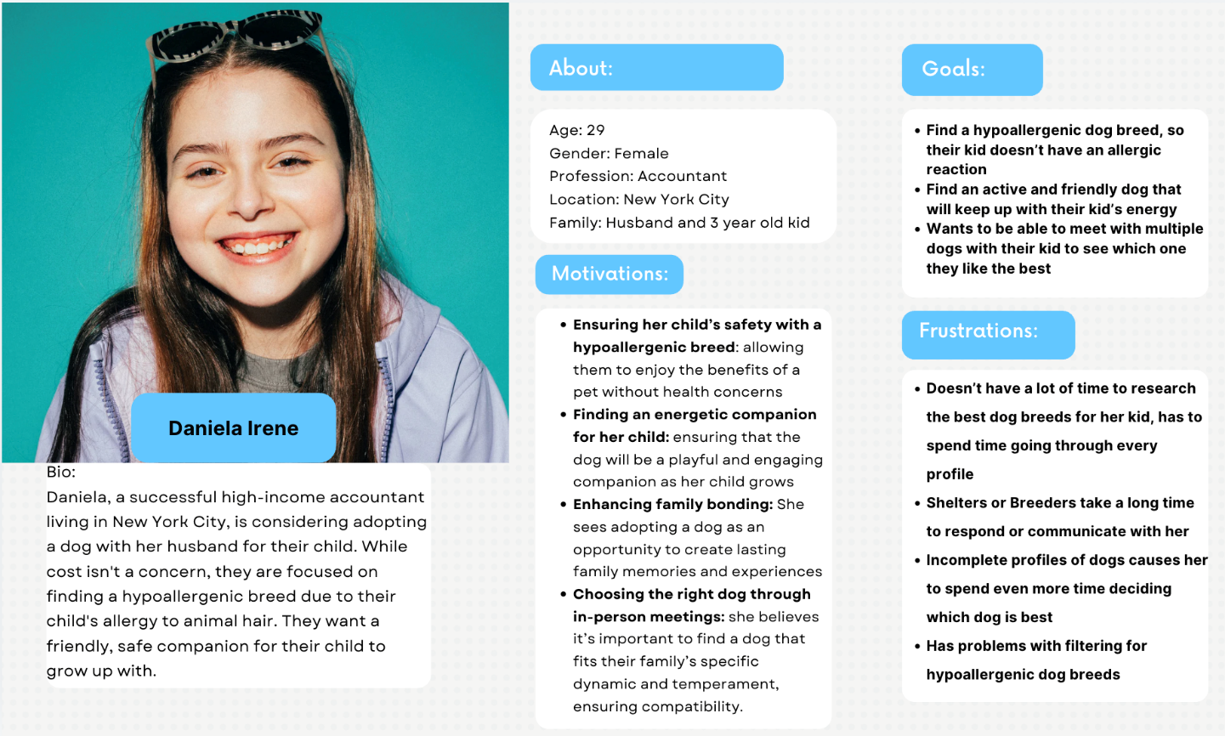

### Scenario:

Daniela, a very family-oriented mother, logs into our pet adoption website to find a hypoallergenic, friendly, and active dog for her 3-year-old. She uses the filtering options in order to find a list of dogs that fit her criteria. After some searching, she found her best match that was highlighted for her. She found a Poodle named Bella, known for being great with kids and highly energetic. Daniela submits an inquiry and questionnaire, hoping to set up a meeting soon. The process was smooth and easy, which helps ease the pressure of finding the right dog as Daniela is determined to find the perfect companion for her child.

### User Story:

* As a caring mother, I want to quickly filter pets by allergy, activity level, and compatibility with kids so that I can find the perfect dog for my kid to grow up with.
* As a first-time pet owner, I want to be given recommendations based on my needs so that I don’t have to spend a lot of time searching through all the pets to find the right one
* As a busy person, I want quick replies to my inquiries so that I can easily schedule time to meet the dog or move on to a different dog if I’m not compatible

## Alejandro Reilly – Employee User

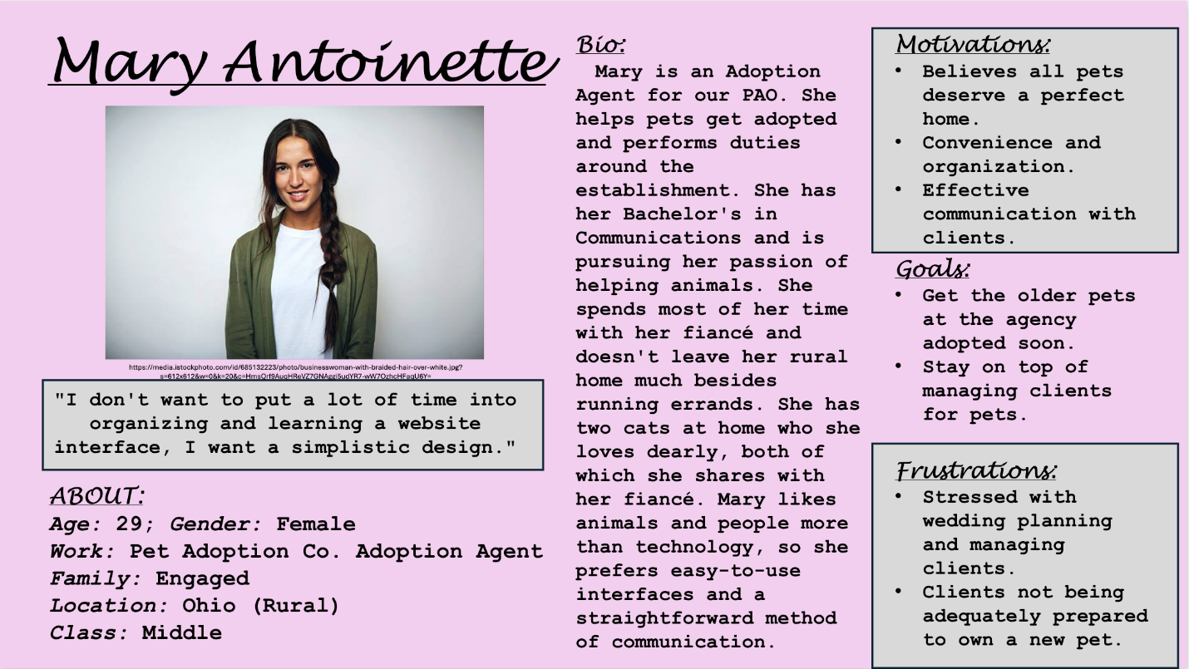

### SCENARIO:

Mary gets a call from a client, and they ask her about a certain pet, Buster the 5-year-old cat’s, availability. Mary responds, saying they are welcome to come and meet him, but they must fill out the questionnaire on their website first. She gives them simple instructions and gets their information for further contact. Mary waits for their application to come in, and after determining that they are an adequate family for adoption, approves their form.

Mary reaches out after approving them, saying they can select which pet they’re interested in (Buster). She views the rest of the clients interested in Buster, and determines this family is the best fit, so she reaches back out and tells them they can come and adopt him.

### USER STORIES:

* As an employee, I need to be able to view the potential adopters' forms so that I can determine if they are a safe person to adopt any pet.
* As a non-tech-savvy person, I want the ability to navigate employee accessible features without a large learning curve on the website, so that I can stay organized and maintain efficiency.
* As a decision-maker for adopters, I want the ability to easily compare potential adopters against each other so that I can see if they are both interested in the same pet.

## Jonathan Le – Admin User

**Persona:**



Name: Jerry

Background Facts:

* Age: 30-35
* Married with kids
* Salary: $75-100K
* Works in the organization's IT department, with high tech proficiency

Motivations:

* Prioritizes efficiency to spend time with family or relax after work.
* Values tools and solutions that minimize unnecessary manual intervention.
* Believes in the importance of the organization's mission to get pets adopted but prefers to support it through tech improvements rather than hands-on involvement.

Frustrations:

* Finds backend components of web applications difficult to interface with due to poor documentation or outdated frameworks.
* Constant tech complaints from non-tech employees and high email volume, which disrupt his focus.
* Struggles with balancing complex tech solutions with the need for simplicity for other employees.

### Scenario:

Jerry logs into the pet adoption web app, hoping for a smooth day so he can leave early to attend his son’s soccer game. However, his inbox is flooded with emails from staff reporting tech issues. Frustrated, he navigates to the backend to fix a form submission problem but struggles with the outdated system and lack of clear documentation.

Pressed for time, Jerry manages to patch the issue but is irritated by how long it took. He wishes the backend interface were more intuitive, allowing him to quickly resolve issues without digging into code, so he can focus on higher-priority tasks—or just go home on time.

### User Stories:

* As an admin, I want to quickly address and resolve backend issues so I can complete my work efficiently and avoid staying late
* As an admin, I want to reduce the volume of tech complaints from employees so that I can focus on more important tasks
* As an admin, I want a user-friendly interface to manage form submission and backend tasks so that I don’t have to parse through complex code to fix minor issues

# Features

## Filter by Dog Size, Activity Level, and Grooming Needs

* Input:
  + User selects preferences for dog size, activity level, and grooming needs through dropdown menus or sliders.
* Activation:
  + User clicks a "Search" button after setting filters.
* Action:
  + The system queries the database to find dogs that match the selected criteria.
* Output:
  + A list of dogs matching Samantha's criteria is displayed on the screen.

## Detailed Breakdown of Adoption Fees and Long-Term Costs

* Input:
  + User clicks on a specific dog’s profile.
* Activation:
  + The system retrieves financial data related to the dog.
* Action:
  + The system calculates both adoption fees and long-term costs (food, vet, grooming).
* Output:
  + A clear breakdown of the costs is shown to the user.

## Online Appointment Booking for Shelter Visits

* Input:
  + User selects a dog and clicks on the "Schedule Visit" button.
* Activation:
  + The system displays available time slots from the shelter's schedule.
* Action:
  + User selects a time, and the system confirms the booking, sending a notification to both the user and the shelter.
* Output:
  + The user receives a confirmation message with appointment details.

## Online Verification Form - Alex

* Input:
  + Users fill their information in the provided questionnaire.
* Activation:
  + Users click the available questionnaire in the system.
* Action:
  + User submits the form after entering their questions and it gets stored into the website’s database.
* Output:
  + Users see a confirmation message, letting them know they will receive a communication after their form is reviewed.

## Login Page - Alex

* Input:
  + Users can enter their login details.
* Activation:
  + Users select the “login” option on the website page.
* Action:
  + Users can create an account, login, or employees can login to their respective sign-in page.
* Output:
  + Users are directed back to the main home page with their respective access and saved data.

## Method of Comparing Potential Adopters - Alex

* Input:
  + Employees choose between two potential adopters that they want to compare for one specific pet.
* Activation:
  + Employees select a “compare adopters” option underneath the correct pet.
* Action:
  + Employees select two of their potential adopters and can easily compare them side-by-side to make a decision on who’s the better fit.
* Output:
  + No visible output.

## Potential Adopters Page - Alex

* Input:
  + Employees click on a “Potential Adopters” button visible only to them.
* Activation:
  + Employees must log-in to see the option, and then click on the button “Potential Adopters”.
* Action:
  + Employees can view the summaries of the potential adopters, and potentially edit them. This includes contact information, questionnaires, and names. There is a search bar for employees to filter through, as well.
* Output:
  + All potential adopters with accounts in the system.

## Detailed Dog Temperament and Compatibility Information:

* **Input**:
  + User clicks on a dog’s profile
* **Activation**:
  + The system displays information about the dog’s temperament, including how well they get along with kids, other pets, and specific needs
* **Action**:
  + The system provides additional insights into how the dog interacts with children and the household environment
* **Output**:
  + Users can easily see whether the dog is a good match for their family’s dynamics

## Virtual Meet-and-Greet Option:

* Input:
  + Users select a dog and clicks the “Request Virtual Meet” button
* Activation:
  + The system displays a list of available video call slots with the shelter for a virtual meet-and-greet
* Action:
  + User selects a time, and the system schedules the video call, sending confirmations to both them and the shelter
* Output:
  + Users get the opportunity to virtually interact with the dog before scheduling an in-person visit

Dog’s Health and Allergy Information:

* **Input**: User clicks on a dog’s profile
* **Activation**: The system retrieves detailed health records, including vaccinations, medical history, and hypoallergenic traits
* **Action**: The system highlights whether the dog has any known allergies, medical conditions, or hypoallergenic traits, helping users ensure the dog is safe for their child
* **Output**: Users receives a clear, transparent summary of the dog’s health, which helps her make an informed decision

Dashboard for Logs, Statuses, Visuals, and DB Access

* Input:
  + Admin views error logs, submission statuses, data visuals, and database access through the dashboard.
* Activation:
  + Admin selects specific logs, data, or queries via the dashboard's interface.
* Action:
  + The system retrieves logs, submission statuses, and runs queries based on admin input.
  + The system generates data visuals for easy interpretation.
* Output:
  + Error logs, submission statuses, and data visuals are displayed.
  + Query results are shown on the dashboard for troubleshooting.

Automated Critical Issue Notifications

* Input:
  + The system identifies critical issues (such as submission errors or system failures).
* Activation:
  + The system triggers notifications when pre-set thresholds for critical issues are reached.
* Action:
  + The system sends out email or SMS notifications with a link to the error.
* Output:
  + The admin receives a notification (via email or SMS) with details of the issue and a link to resolve it.

Embedded Troubleshooting Guides and API Docs

* Input:
  + Admin accesses embedded troubleshooting guides and API documentation in the admin panel.
* Activation:
  + Admin clicks on a guide or documentation link while handling errors or working with APIs.
* Action:
  + The system displays the relevant guide or API documentation in the admin panel.
* Output:
  + The admin views the troubleshooting steps or API information to resolve the issue.